

Business Analytics

Syllabus

2 ECTS
BBA, 2024-2025

Barcelona, 2025


Table of contents
1. Course description / Introduction to the course 1
2. Learning objectives 1
3. Course format and methodological approach 2
4. Course Contents 3
5. Assessment 4
6. Materials 7
7. Faculty leading the course 8
8. Timetable 9
Annex. The ESADE Honour Code 10

1. Course description / Introduction to the course

This course introduces students to the fundamental tools and techniques used in Business Data Analytics, with a particular focus on real-world applications. The course is designed to equip students with the practical skills needed to extract insights from data, make data-driven decisions, and communicate results effectively using both Excel and Python.
The first part of the course focuses on spreadsheet-based analysis, covering essential Excel functions, data manipulation techniques, and pivot tables. In the second part, students transition to Python, where they will explore core libraries for data analytics and apply them to business case studies related to marketing, product performance, and user behavior.
The course emphasizes hands-on learning through decision-making scenarios in a simulated business environment. Students will work with real datasets, make strategic decisions.
This course provides students with a solid foundation in business analytics, combining technical proficiency with a business-oriented mindset for problem-solving.

Pre-requisites: Descriptive Statistics and Probability
Prior knowledge:
- The concepts of Real functions, Continuity, Differentiability, Definite integral, Matrix calculus
- Descriptive Statistics and Probability main concepts such as:
  - Understand, use and apply unidimensional and bidimensional frequency distributions, and interpret suitable graphs.
  - Understand, use and calculate measures of central tendency, variability and relationship between variables.
  - Understand basic concepts related to the probability field.
  - Define probabilities, understand their properties.
- Willingness to engage with Python as a tool for data exploration and decision-making

2. Learning objectives
Upon successful completion of this course, students will be able to:
- Leverage Excel and Python to analyze business data and extract actionable insights.
- Develop data-driven decision-making skills through hands-on simulations in the context of a real company.
- Apply analytical techniques to evaluate and shape company strategy across different departments.
- Understand how to structure and communicate business insights effectively to stakeholders.
- Recognize the strengths and limitations of different tools and approaches in real-world business scenarios.
- Foster a mindset of ethical, responsible, and evidence-based decision making.

3. Course format and methodological approach
The course is organised into 6 sessions of 2h 30min duration. Each of them consists of a mix of autonomous work done by the students out of class hours (which will provide students with highly valued competencies in the current working environment, such as self-management and problem resolution) and Class sessions.

The first two sessions of the course will focus on Excel, with the goal of consolidating the theoretical concepts studied in the Descriptive Statistics course and applying them to real-world business scenarios.

•Session 1:
We will explore key Excel functionalities in depth together, covering formulas, data handling, and basic analysis tools. The final part of the session will be dedicated to a short, guided exercise to put these skills into practice.

•Session 2:
The session will begin with a brief recap of key takeaways from the first class. Afterwards, students will work in groups to tackle a more comprehensive business case, applying Excel tools to analyze and draw insights from data.

The other 4 sessions will be Python based. Students will use Google Colab notebooks, which will serve as the primary working environment. Each session will follow a consistent structure featuring two main notebooks:

1.Notebook 1 (Approx. 1 hour 30-45 minutes):
This notebook introduces the key concepts for the day in a more theoretical format. It will include a mix of solved and unsolved examples, which we’ll work through together as a class.

2.Notebook 2 (Group Work):
The second part of the session focuses on practical application. Students will work in groups to solve exercises based on realistic business analytics cases for the fictional video game company Entero and its latest game, Globba.

Students will be required to submit their group exercises by end of day (EOD), providing some extra time for completion. Solutions will be shared at midnight for self-assessment and review.

All materials and resources for the course will be provided in English. Note that this also includes the final exam questions.

Excel and Python will be used as the main course tool . Students should bring their laptops to all sessions, and make sure, prior to each of them, that the Excel® license provided by Esade is available and running.

4. Course Contents
The 6 session of this course have the following learning objectives and contents:

Session 1 & 2 : Introduction to Excel
Upon completing these sessions, students should be able to:
- Basic usage of Excel such as data entry and formatting, use of formulas and functions, absolute and relative references (dollar sign usage), and basic data visualization techniques such as charts and plots.
- In addition, students will learn to summarize and analyze datasets using PivotTables, enabling them to extract key insights and support business decision-making.
- Usage and calculation of measures of central tendency, variability and relationship between variables.

Session 3. Introduction to Python
In this session, students will be introduced to the fundamentals of programming in Python using the Google Colab environment. The session will cover:
- Overview of the Google Colab ecosystem: navigating, creating, and running notebooks
- Python basics, including:
  - Variables and data types (integers, floats, strings, booleans)
  - Core data structures (lists, dictionaries, tuples, and sets)
  - Control flow (if-else statements, loops)
  - Writing and using functions
  - Importing and using libraries (e.g., math, random, pandas)
  - Reading external files (CSV and text files)
This session aims to ensure all students, regardless of their prior programming experience, acquire a common foundational skill set in Python to support the upcoming business analytics applications.

Session 4. Data Analysis with Python
This session focuses on building practical data analysis skills using the Pandas library, one of the most widely used tools for data manipulation in Python. Students will learn to handle real-world datasets through the following topics:
- Introduction to Pandas: setting up and understanding the structure of DataFrames
- Reading and writing DataFrames: loading data from CSV and exporting results
- Basic DataFrame manipulations: renaming, sorting, filtering, and handling missing values
- Working with rows: selecting, slicing, and iterating
- Working with columns: creating new columns, applying functions, and column transformations
- Subqueries and Boolean indexing: applying conditional logic to filter data
- Merging and concatenating: combining multiple datasets effectively
- Introduction to plotting: creating basic visualizations using Pandas’ built-in plotting tools
By the end of the session, students will be able to clean, transform, and analyze datasets using Pandas, preparing them for more complex business analytics tasks in subsequent sessions.

Session 5. Statistics for Data Analytics
This session deepens students’ understanding of descriptive statistics and their role in analyzing business data, with a focus on hands-on applications using Pandas.
Upon completing this session, students should be able to:
- Compute and interpret measures of central tendency and dispersion in a dataset.
- Detect outliers using statistical rules and visualize distributions effectively.
- Analyze relationships between variables using correlation and visualization tools.
- Apply basic probability concepts to interpret business metrics under uncertainty.
Session 6. Introduction to Causality
This session introduces students to causal thinking and the A/B testing methodology as a structured way to make better product and business decisions based on data.
Upon completing this session, students should be able to:
- Understand why A/B testing is used in business settings
- Explain the logic behind testing changes using control and treatment groups
- Describe the key components of a well-designed A/B test
- Interpret the outcome of an experiment from a business perspective

5. Assessment
Students’ final grade for Business Analytics consists of the following elements:
50% - Students’ continuous assessment:
- 10% - Class participation, interaction, and teamwork
- 25% - Group assignments and exercises submissions
- 15% - Average of the Individual Assessments (End of session 2,4,6) (Best 2 out of 3)
50% - Final Exam
- Mix of Excel and Python short exercises.
Evaluation of the final grade will consider any applicable policies set forth within the course or at Program level; please take a close look at the Program’s honour code at the end of this document.

Class participation, interaction, and teamwork
Students will be allowed to miss up to 20% of the class hours, which corresponds to 1.2 sessions. Absences may only be excused with the approval from Program Management. Students who are absent for 1.2 or more sessions will not be allowed to pass the course and will be required to do the retake exam. In addition, students who are absent for more than 50% of the class hours (i.e. 3 sessions), regardless of the absences being justified or not, will not be allowed to pass the course and will be required to retake the exam.

It is expected that students will arrive on time, both at the beginning of a session and after a break. A 5-minute courtesy will be extended for every session. Students arriving late will be allowed to enter the class but will be penalized for their late arrival. Their attendance register for class will only count 75% of the class. In addition, punctuality and class behavior will also be considered in the class participation grade.

Participation in all sessions will be highly valuable to students’ autonomous learning. Class participation and interaction also includes effective teamwork participation. Grading teamwork is necessarily subjective, however the faculty will attempt to make it as objective as possible. The criteria for evaluating effective team participation include dedication, effort, and respect for the team and its members, and a collaborative attitude.

If a student behaves inappropriately in class, their class participation grade will automatically be a zero

Individual Assessment
As stated before, sessions 2,4 and 6 will end with an Individual Assessment. If a student is not in class during such a Class session, the grade of the corresponding Individual Assessment will be zero. If a student arrives in the middle of the Class session, they may take the assessment with a penalization of 1 point (out of 3).
If a student does all three tests, then the lowest grade will be dropped (Best 2 out of 3)

Final exams
A final exam will take place to assess each student's knowledge about the topics covered in the course. Thus students should expect a mix of Excel and Python exercises.
The exam will take place on the 30th of May from 11:30 until 13:30.
The average of the final exam must be at least equal to 3.5 (out of 10) to be able to compute the course average. If this minimum grade is not achieved, the final course grade will be the retake exam grade.

6. Materials
Support slides, lists of exercises and solutions, and case resolutions will be made available on the course website.
Excel and Python will be used as the main course tool. This means that students should bring their laptops to all Class sessions to be able to use it.
The first two days of the course will be devoted to Excel; therefore, students have to make sure Excel is properly installed in their devices.
For Python sessions Google Collab will be the chosen environment. The aim was to not force students to perform local installations such as Conda or JupyterLabs.

7. Faculty leading the course
Gerard Martínez, Coordinator. After completing bachelor's degrees in Mathematics and Business Administration, Gerard pursued a Master's degree in Data Science at the University of Barcelona, where he discovered his passion for squeezing data until they confess. Currently he crunches numbers and tries to understand players’ behavioural patterns in the videogaming company King Games, and more specifically for Candy Crush Saga (yes it's still a thing! ). In his spare time, Gerard stays engaged with developments in AI/ML, Finance, and the entrepreneurial ecosystem (trying to be less of a consumer, and more of a producer. Let's build !)
Gerard Martínez is about to start his teaching practice at ESADE, and while the nerves are there, his excitement and eagerness to learn far outweigh any fears.
Contact: gerard.martinez4@esade.edu
Office hours: By appointment

Administrative support. Department of Operations, Innovation and Data Sciences:
Ms. Mode Guillen and Ms. Donka Jeleva
Contact: oids@esade.edu
Location: Sant Cugat Campus
8. Timetable
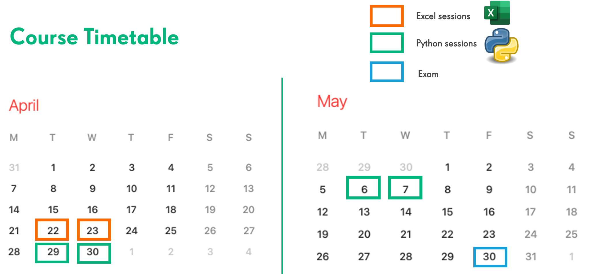

Date | Session | Comments
22nd of April | Introduction to Excel | Excel Session
24th of April | Data analysis with Excel | Excel Session
29th of April | Introduction to Python | Python Session
30th of April | Data Analysis with Python | Python Session
6th of May | Statistics for Data Analytics | Python Session
7th of May | Introduction to Causality | Python Session

Annex. The ESADE Honour Code
This course is strictly ruled by ESADE’s Honour Code
"I will not lie, cheat or steal to gain an academic advantage. I will respect all ESADE students, faculty and staff with my words and deeds."
The violations of the ESADE MBA Honor Code include the following:
Lying: Lying includes knowingly communicating an untruth in order to gain an unfair academic or employment advantage.
Cheating: Cheating includes, but is not limited to, using unauthorized materials to complete an assignment; copying the work of another person; unauthorized providing of materials or information (e.g. proprietary course information) to another person; plagiarism; unauthorized providing of materials or information to another person during an exam. All communications, written, oral or otherwise, among students during examinations, are forbidden, as is the use of notes, books, computers, calculators or other written material except when approved by the instructor.
Stealing: Stealing includes, but is not limited to, taking the property of another member of the ESADE community without permission, defacing or vandalizing the property of the ESADE Business School, or the misuse of ESADE resources.
Respect for others and professional conduct: Respect for others includes treating all ESADE students, staff, faculty and external contacts connected to the school with politeness and cordiality, refraining from using abusive language or physical violence.
Upon witnessing a violation of the Honour Code, a student has a moral obligation to inform the student whose conduct is believed to be in violation of the Code that the Code has been violated. Each member of the ESADE MiBA community, as a person of integrity, has a personal obligation to adhere to this requirement, both on campus and when representing ESADE off campus.
Failure to comply with the more explicit guidelines set forth by the Programme’s Rules and Regulations can also be considered as a breach of the Honour Code.
Violations of this agreement and will be governed by MiBA Programme Management which has the right to exercise any disciplinary action necessary in order to uphold the standards set forth herewith and in the Programme’s Rules and Regulations.

